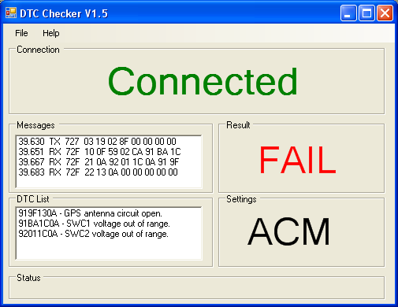
Displays status of ValueCAN Hardware.
Reports the result of the DTC Check.
Reports the result of the DTC Check.
Reports the raw CAN data.

Above shows various callouts for each section of the DTC Checker Tool. In a nutshell the tool is supposed to be the last stop on the PDI station. It checks the DTCs for a selected product and determines Pass/Fail based on the results it receives. In general I would say it is a versatile tool that can be continuously changed/updated to meet the needs as we see fit.

Using File->Setup the user can adjust the settings. This settings menu as showed below shows that the DTC Checker supports all ACM, EFP and LXF products for Ford.

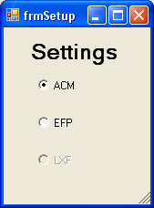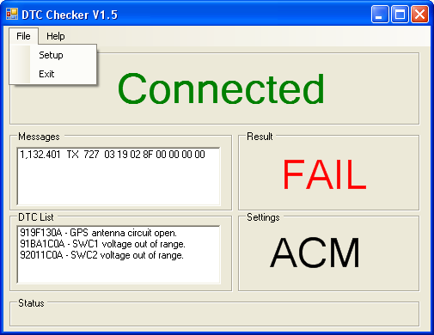
User can change between ACM, EFP, or LXF products.

A typical pass for ACM…
Note: All ACMs ship to Ford with one DTC present. Then Ford configures the module and clears this DTC.

